Français 9/10 Je m’appelle ________________________
Projet – La santé et la routine quotidienne
- Affiche – la santé /20
- Create a poster promoting/informing of an aspect of a healthy lifestyle
Include: * at least 3 commands (make 1 in the negative form)
* a variety of vocabulary from this chapter (minimum 5)
* at least one new verb (IR #3/Savoir/Connaître)
- Remember it is a poster – so do not write LONG paragraphs – keep it easy to read!

Incomplete | Emerging | Developing | Proficient | Extending
Poster is unclear or incomplete. | Poster is unclear at times with errors in grammar/structure that prevent understanding. Vocabulary is often incorrect or repetitive. | Poster is mostly clear with occasional errors in grammar/structure. Vocabulary may be misused at times. | Poster is clear with minor grammatical/structural errors. Vocabulary is usually varied and an understanding of commands is demonstrated. | Poster is clear, detailed, logical with minimal grammatical/structural errors only when risks are taken. Vocabulary is varied and a clear understanding of commands is evident.

- Orale - Une Journée Typique /20
- Create a visual about a typical day in your life.
- You need a minimum of 6 reflexive verbs.
- You need a minimum of 4 “normal” verbs.
- Include Greeting/intro with your title page and a conclusion
- Use a variety of vocabulary from this French9/10
- From memory, describe a day in your life to the class.
*THE ONLY WORDS IN YOUR POWER POINT ARE YOUR TITLE PAGE AND YOUR NAME*
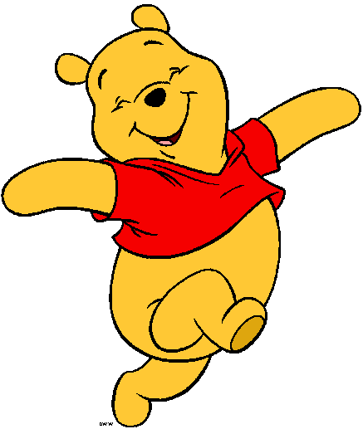

 | Incomplete | Emerging | Developing | Proficient | Extending
Vocabulary | Vocabulary is in English/Google translate is evident | Vocabulary is often incorrect or repetitive. | Vocabulary may be misused at times. | Vocabulary is usually varied and an understanding of reflexives is demonstrated. | Vocabulary is varied and a clear understanding of reflexives is evident.
Clarity + Pronunciation (*speaking) | 7+ errors. Speech is unclear. | 5-6 errors. Speech is unclear at times. | 3-4 errors. Speech is mostly clear. | 1-2 errors. Minor pronunciation or structure errors | All pronunciation rules are followed.  Minor errors only on complex /new words.  Varied intonation.
Fluidity  (*speaking) | Requires assistance/uses a script. | Requires occasional assistance or sentences are often unclear or incomplete. | Sentences are mostly clear and complete. Minimal assistance is required. | Sentences are clear and complete. No assistance is required. | Sentences are complete, clear, fluid, and well thought out. No assistance is required. Slides match watch is being said.

