Avoir = to Have

J’ ai Nous avons
(I have) (We have)

Tu as Vous avez
(you have) (you have)

Il/Elle
On/Qui a Ils/Elles ont

Tout le monde (They have)
(He/She
One/Who has)
Everyone

Exemple : I have = J’ai You do NOT have = tu n’as pas

Expressions with avoir :
Quel âge as-tu? = How old are you? J’ai 14 ans.=I am 14 years old.
Il y a =There is / There are J’ai faim = I am hungry
J’ai soif = I am thirsty
Practice!

j’ _______ai__________ il _______a__________ mon père ___a__________
elle ________a______ ils _______ont__________ elles ___ont_____
nous ______avons__________ tu _______as________ vous ___avez___________
elles ______ont___________ nous ______avons_____ le voisin __a___________
on ______a___________ qui ______a________ j’ ___ai__________
tu ______as___________ vous ______avez_______ mon neveu __a_________
le prof ___a______________ les filles _ont________ les profs __ont_______
vous ____avez__________ t.l.monde ____a_________ tu _as____________
la fille ______a__________ ma mère ___a____________ ma souer et moi __avons_______

B : Practice!
- I have __j’ai_______ 11. The uncle has l’oncle a
- The cat has le chat a 12. You (pl) have __vous avez__
- He has _Il a________ 13. The dog has le chien a
- We have nous avons 14. She has __elle a__________
- You (s) have _____tu as__________ 15. The dad has le père a
- The aunt has la tante a 16. Who has _______qui a______
- You (pl) have ___vous avez_________ 17. Paul has Paul a
- They (m) have _ils ont_____ 18. The sisters have les soeurs ont
- The brothers have les frères ont 19. You (s) have _ tu as
- The family has la famille a 20. Everyone has tout le monde a
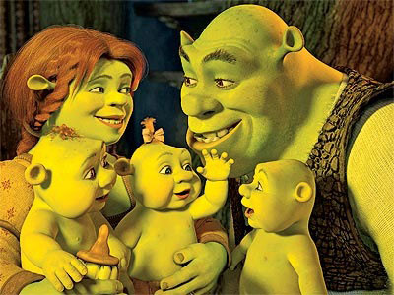
C : Write in French:
- Fiona has 3 kids. __ F a trois enfants.______
- Fiona has a husband. He is called Shrek.
F a un mari. Il s’appelle Shrek.
- Shrek doesn’t* have hair, but he has small ears.
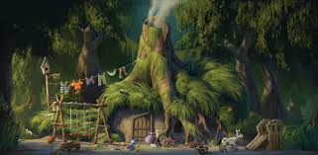Shrek n’a pas de cheveux, mais il a des petites oreilles.
- 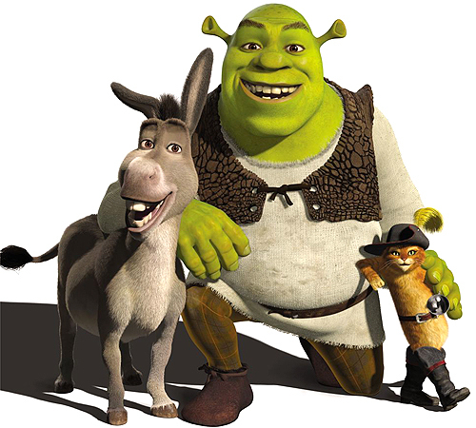Shrek is green and nice. He lives in a swamp (un marais).
Shrek est vert et sympa. Il habite dans un marais._
- Shrek has some friends. Donkey talks a lot. The cat is called Puss ‘n Boots.
Shrek a des amis/copains. Donkey parle beaucoup. Le chat s’appelle Puss n Boots______
- The friends have lots of adventures. Les amis ont beaucoup d’ aventures
- Do you have the video “Shrek?” Tu as la vidéo ?
- We don’t have twins in the class. Nous n’avons pas de jumeaux dans la classe
- Shrek is forty years old. Shrek a quarante ans

